PCA demo

PCA Exercise 1 : Example book "statistical analyses using R"
Variables: sports; observation: competitors
Observations: 25 competitors
A scoring system was designed to assign points to the results of each event and the winner is the one that accumulates most points.
Question: is this a good scoring system? are the scores of the different sports related to each other, e.g. if you are good in running are you also good in javelin because if this is not the case the scoring system is not good. This means we will look for redundancy in the data (marks for running and e.g. jumping should be correlated and contribute to the same direction of variance in the data).
Load the data; the last column contains the overall scores of the competitors and we will remove this column. Data will be plotted. It is obvious that there exist a positive correlation amongst most of the sports. So e.g. a competitor that performs well on hurdles also performs well on high jump. Only with javelin the correlation is less obvious. This means that training in the other sports does not increase the performance in javelin per se. This is confirmed by calculating the correlation.
data("heptathlon", package = "HSAUR")
head(heptathlon)
score<-which(colnames(heptathlon)==”score”)
plot(heptathlon[,-score])
round(cor(heptathlon[,-score]),2)
# 2 means we round the correlation values at two digits
hurdles highjump shot run200m longjump javelin run800m
hurdles 1.00 -0.81 -0.65 0.77 -0.91 -0.01 0.78
highjump -0.81 1.00 0.44 -0.49 0.78 0.00 -0.59
shot -0.65 0.44 1.00 -0.68 0.74 0.27 -0.42
run200m 0.77 -0.49 -0.68 1.00 -0.82 -0.33 0.62
longjump -0.91 0.78 0.74 -0.82 1.00 0.07 -0.70
javelin -0.01 0.00 0.27 -0.33 0.07 1.00 0.02
run800m 0.78 -0.59 -0.42 0.62 -0.70 0.02 1.00
Now we will perform PCA. The PCA function performs and internal centering and rescaling so that means =0.
heptathlon_PCA <-prcomp(heptathlon[,-score], scale =TRUE)
print(heptathlon_PCA)
summary(heptathlon_PCA)
standard deviations:
[1] 2.1119364 1.0928497 0.7218131 0.6761411 0.4952441 0.2701029 0.2213617
Rotation:
PC1 PC2 PC3 PC4 PC5 PC6
hurdles 0.4528710 -0.15792058 -0.04514996 0.02653873 -0.09494792 -0.78334101
highjump -0.3771992 0.24807386 0.36777902 -0.67999172 -0.01879888 -0.09939981
shot -0.3630725 -0.28940743 -0.67618919 -0.12431725 -0.51165201 0.05085983
run200m 0.4078950 0.26038545 0.08359211 -0.36106580 -0.64983404 0.02495639
longjump -0.4562318 0.05587394 -0.13931653 -0.11129249 0.18429810 -0.59020972
javelin -0.0754090 -0.84169212 0.47156016 -0.12079924 -0.13510669 0.02724076
run800m 0.3749594 -0.22448984 -0.39585671 -0.60341130 0.50432116 0.15555520
PC7
hurdles -0.38024707
highjump -0.43393114
shot -0.21762491
run200m 0.45338483
longjump 0.61206388
javelin 0.17294667
run800m 0.09830963

Inportance of components:
PC1 PC2 PC3 PC4 PC5 PC6 PC7
Standard deviation 2.1119 1.0928 0.72181 0.67614 0.49524 0.27010 0.2214
Proportion of Variance 0.6372 0.1706 0.07443 0.06531 0.03504 0.01042 0.0070
Cumulative Proportion 0.6372 0.8078 0.88223 0.94754 0.98258 0.99300 1.0000

#proportion of the variance explained
var_explained=( heptathlon_PCA $sdev[])^2
tot_var = sum((heptathlon_PCA $sdev[])^2)
proportion_of_variance =var_explained/tot_var
#note these values are identical to summary(heptathlon_PCA)
Check the loading of the different sports on the first PC
heptathlon_PCA$rotation[,1]
hurdles highjump shot run200m longjump javelin run800m
0.4528710 -0.3771992 -0.3630725 0.4078950 -0.4562318 -0.0754090 0.3749594
The hurdles and the long jump receive the highest weight but the javelin is less important. Note that on the second PC the importance of javelin is the most pronounced. Thus illustrates the two major directions of variability in the data.
For computing the score of the data on the PCs (or the projection of the data on the PC), the data need to be rescaled. The center and the scaling used by prcomp internally can be extracted from the heptathlon_PCA via
center_hept = heptathlon_PCA$center
mean(heptathlon$hurdles)

hurdles highjump shot run200m longjump javelin run800m
13.8400 1.7820 13.1176 24.6492 6.1524 41.4824 136.0540

scale_hept <- heptathlon_PCA$scale
sqrt(var(heptathlon$hurdles))

hurdles highjump shot run200m longjump javelin run800m
0.73664781 0.07794229 1.49188438 0.96955712 0.47421233 3.54565612 8.29108809

hm<-as.matrix(heptathlon[,-score])
hm_scale = scale(hm, center=center_hept, scale=scale_hept)

Being scaled properly means that the mean equals =0 and the variance is 1 per column
mean(hm_scale)
[1] 8.084307e-17
var(hm_scale[,1])

Now the scores can be calculated by performing the matrix transformation PX =Y
Where P is the matrix containing in its rows the PC and X is the matrix containing in its columns the observations (see slide theory)

the observation
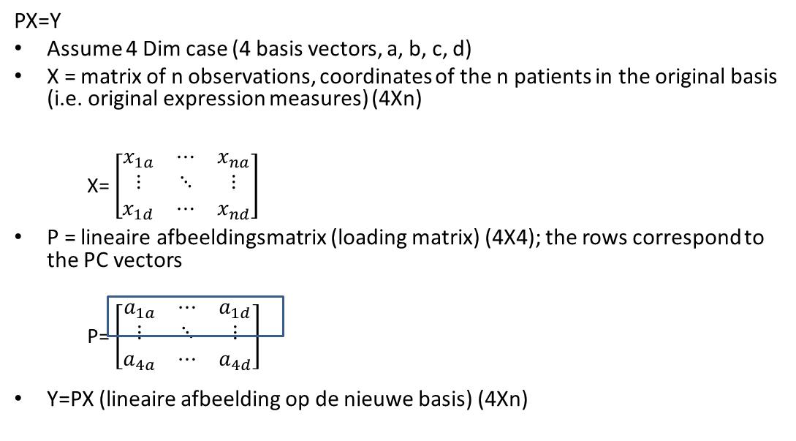
R provides heptathlon_PCA$rotation where now the PC are the column vectors. So rather than using PX= Y = we will use X^{T}P^{T} with X^{T} containing the observations in the rows.

scale(hm, center=center_hept, scale=scale_hept)%*%heptathlon_PCA$rotation[,1]
#check dimensions 25*7 7*1
dim(as.matrix(scale(hm, center=center, scale=scale)))
dim(as.matrix(heptathlon_PCA$rotation[,1]))

[,1]
Joyner-Kersee (USA) -4.121447626
John (GDR) -2.882185935
Behmer (GDR) -2.649633766
Sablovskaite (URS) -1.343351210
Choubenkova (URS) -1.359025696
Schulz (GDR) -1.043847471
This is identical to
predict(heptathlon_PCA)[,1]
which is the projection of the observations on the first PC
biplot(heptathlon_PCA, col = c("blue", "red"))

oyner-Kersee (USA) John (GDR) Behmer (GDR) Sablovskaite (URS)
-4.121447626 -2.882185935 -2.649633766 -1.343351210

#plot the observations in their new axis (each point is a competitor for which the score is plotted, each arrow is the loading of the sport on the new axes).
layout(matrix(1:2,ncol=2))
plot(predict(heptathlon_PCA)[,1],predict(heptathlon_PCA)[,2])
points(predict(heptathlon_PCA)[,1],predict(heptathlon_PCA)[,2], col="red")
title("scores")

#plot the loadings
plot(heptathlon_PCA $rotation[,1], heptathlon_PCA $rotation[,2])
text(heptathlon_PCA $rotation[,1], heptathlon_PCA $rotation[,2], labels= colnames(heptathlon),cex=0.8,col="red")
title("loadings")

cor(heptathlon$score, predict(heptathlon_PCA)[,1])
= -0.9910978

This implies that the first principal component is in good agreement with the official scores assigned to the athletes.
Conclusion: the scoring system is representative. All sports, except javelin contribute to the same direction of variance.

